Session 2026-2027

Vision:Dream of where you want. | Mission: Means to achieve Vision

Program Educational Objectives of the program (PEO): (broad statements that describe the professional and career accomplishments)
PEO1 | Preparation | P: Preparation | Pep-CL abbreviation  pronounce as Pep-si-lL easy to recall
PEO2 | Core Competence | E: Environment (Learning Environment) | Pep-CL abbreviation  pronounce as Pep-si-lL easy to recall
PEO3 | Breadth | P: Professionalism | Pep-CL abbreviation  pronounce as Pep-si-lL easy to recall
PEO4 | Professionalism | C: Core Competence | Pep-CL abbreviation  pronounce as Pep-si-lL easy to recall
PEO5 | Learning Environment | L: Breadth (Learning in diverse areas) | Pep-CL abbreviation  pronounce as Pep-si-lL easy to recall

Program Outcomes (PO): (statements that describe what a student should be able to do and know by the end of a program)
Keywords of POs:
Engineering knowledge,Problem analysis, Design/development of solutions,Conduct Investigations of Complex Problems, Engineering Tool Usage, The Engineer and The World,Ethics, Individual and Collaborative Team work,Communication, Project Management and Finance, Life-Long Learning

PSO Keywords: Cutting edge technologies, Research

“I am an engineer, and I know how to apply engineering knowledge to investigate, analyse and design solutions to complex problems using tools for entire world following all ethics in a collaborative way with proper management skills throughout my life.” to contribute to the development of cutting-edge technologies and Research.

Integrity: I will adhere to the Laboratory Code of Conduct and ethics in its entirety.

Name and Signature of Student and Date
(Signature and Date in Handwritten)

Session | 2026-27 (ODD) |  | Course Name | Web Technology Lab
Semester | 3 |  | Course Code | 23CT1301
Roll No | 54 |  | Name of Student | Limay Tidke
Practical Number |  | 4 - B
Course Outcome |  | - Understand various internet technologies.  - Design the web pages using HTML and CSS.  - Implement the XML technology to store the data.  - Develop the interactive web pages using JavaScript.
Aim |  | JavaScript — DOM Manipulation
Problem Definition |  | Build a To-Do List web app where users can add,  delete, and mark tasks as complete, using vanilla JavaScript DOM methods only.
Theory  (100 words) |  | Document Object Model (DOM)  When the browser loads an HTML page, it builds an in-memory  model of that page called the DOM.  The DOM represents the page as a tree of elements.  - HTML → creates the structure  - DOM → represents that structure in memory  - JavaScript → uses the DOM to read and change the page  What is DOM Manipulation?  DOM Manipulation means using JavaScript to:  - Find an element  - Read its value  - Change its content  - Create new elements  - Add elements to the page  - Remove elements from the page  - Change its CSS classes
Procedure and Execution  (100 Words) |  | Step for Implementation:  Open a text editor (such as VS Code, Notepad, or Sublime Text).  - Create a new file named practical4a.html.  - Set up the standard HTML structure (<!DOCTYPE html>, <html>, <head>, <body>).  - Add an interactive element, such as an input field and a <button>, to trigger JavaScript execution.  - Define a JavaScript block inside <script> tags to read user input, run a basic greeting function, and dynamically update a heading or paragraph element on the page using the DOM.  - Save the file and open practical4b.html in a web browser.  - Click the button to observe dynamic content changes and inspect the browser console (F12) for output.
Code:

function addTask() {
let task = prompt(`Enter Task: `);
let board = document.querySelector(".board");
return board.innerHTML = `<div class="task"> <h4 id="task_id">${task}</h4></div> <div> <button type="button" id="delete" onclick="delete()"> Delete </button></div>` + board.innerHTML;
}

function clearAll() {
let board = document.querySelector(".board");
return board.innerHTML = ``;
}
Output:
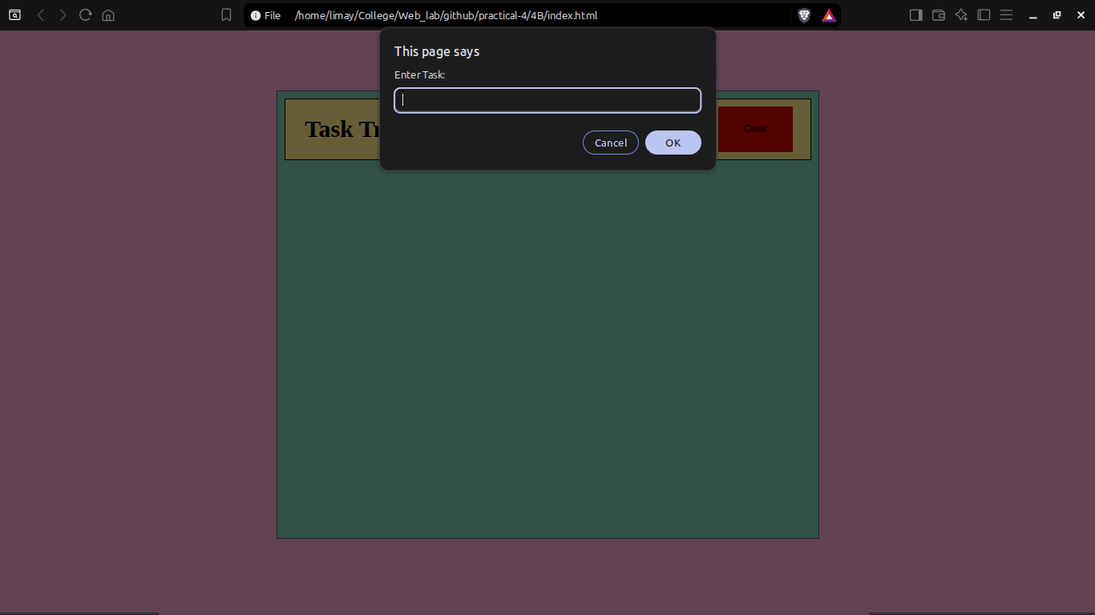
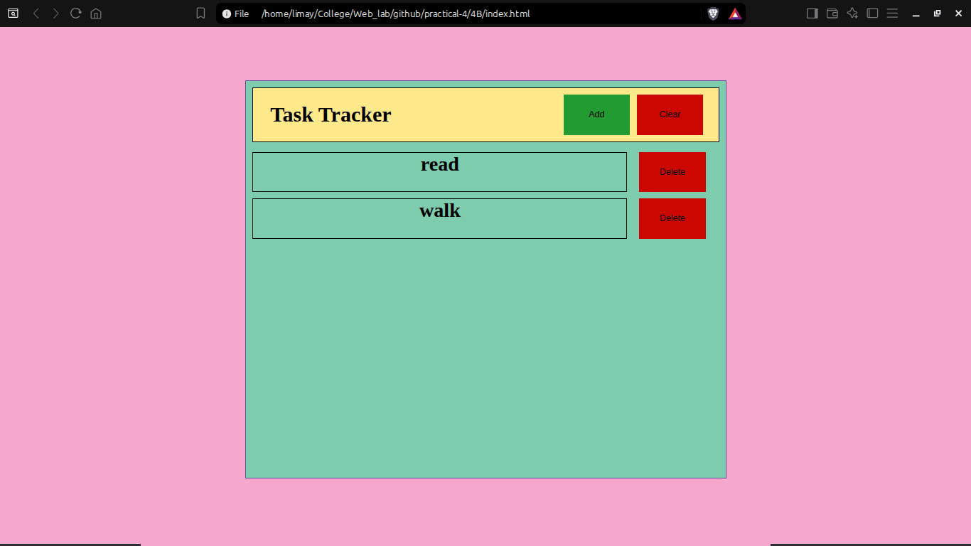
Output Analysis |  | Initially the task board was empty  - On clicking “Add” : The website prompts the user to type out a task and then creates a div and adds it to the main task board.  - On clicking “Clear” : The website clears the entire board of the list created.  - On clicking “Delete” : The website clears only the that specific task.
Link of student Github profile where lab assignment has been uploaded |  | https://github.com/limaytidke
Conclusion |  | Successfully studied the fundamentals of JavaScript and demonstrated dynamic client-side scripting, event handling, and DOM element manipulation in a web environment.
Plag Report (Similarity index < 12%) |  | 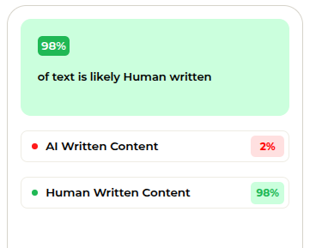
Date |  | 15/09/2026

